A code was written using a couple engineering equations, several assumptions to simplify the problem, and the values given by what Thorcon had provided. Many of these assumptions stemmed from the values thor con provided.

**Assumptions**

* Pressure increases are caused by the pump as shown in the figure below of a typical supercritical steam cycle
* 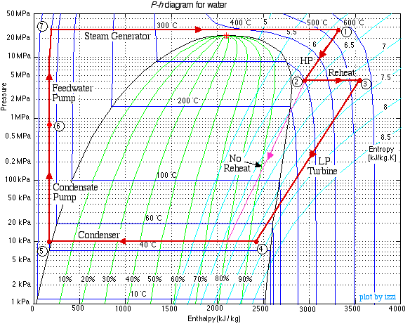
* Reheat Exit temperature is the same as the steam generator exit temperature
* Flow rate decreases from 225 → 162 before and after the high pressure turbine. Let us assume that this flow rate decrease constant or that the flow rate always drops [(225-162)/225]*100% between main and reheat
* Pressure drops 260 → 248 through the steam generator so let's assume that pressure always drop [(260-248)/260]*100% through steam generator
* Pressure drops through other components are negligible
* LP turbine exit temp and pressure are always 32C and 0.05 bar
* HP turbine exit temperature is 343C and entropy increase is determined by the current system or [(6.1396-6.5662)/6.1396]*100% (The percentage increase in entropy in the thor con full capacity operating scenario)
  + This determines the exit pressure of the steam after the HP turbine. We can use an idealized turbine as well where no entropy gain is made

according to bernoulli's assuming no height difference, the change in pressure will cause a change in the square of the velocity.



Mass flow rate is directly proportional to the velocity (m_dot=rho*A*v. We assume that A stays constant and rho stays constant since the pressure increase happens in subcooled water before it enters through the steam generator).

This velocity is proportional to the square root of the pressure and thus mass flow rate is proportional to the square root of the pressure. We can also say the following:

$m_{0}/{P_{0}}^{2}=m_{}/P^{2} or m=m_{0}{P_{0}}^{2}/P^{2}$

Here m is the mass flow rate and the 0 subscript refers to the values given by thor con’s values

**The Code**

How the code works is that it first solves for the steam generator exit temperature using the equation for counterflow heat transfer Q=UA**Δ**Tlm. **Δ**Tlm needs the variables T_hot_in, T_hot_out, T_cold_in, and T_cold_out. T_cold_out (the steam exit temperature) is the value we are solving for. We know what Q is since we can arbitrarily set that value and we know what T_hot_out and T_cold_in are since those are constrained by our system (artificial restraints we place on the system such that we do not mess with the other loops). T_hot_in is determined by how much energy we use for hydrogen production.

*One issue with this temperature guessing approach is that the Q=UA****Δ****Tlm equation makes no heed of mass flow rate. I*

Pressure

Now the next part is rather tricky since this system has reheat and a LP and HP turbine and there is the mass flow rate drop. What the code does then more or less educated guessing through a while loop until all the constraints placed on the system from the assumptions above are accounted for along with the mass flow rates matched with the enthalpies providing the Qin that we arbitrarily set. Why a guessing algorithm needs to be implemented is from what was stated in the assumptions before.

Qin=mass_flow_rate\***Δ**h[enthalpy]

Now both mass flow rate and the enthalpy are a function of pressure and thus if we arbitrarily increase the mass flow rate, then the Qin we calculate through the SG may not match up with the Qin that we set initially.

*One issue with this guessing algorithm is that there exist a lot of combinations of mass flow rates and enthalpy that provide the correct Qin so it is possible that the algorithm picks the first working one it finds and not the correct one*

**Code Results**

Energy fraction is started at 10% since 1) it is unlikely that we will operation the plant at 10% power what with efficiency losses and 2) the ΔTlm generates improper values when the Qin is that low.

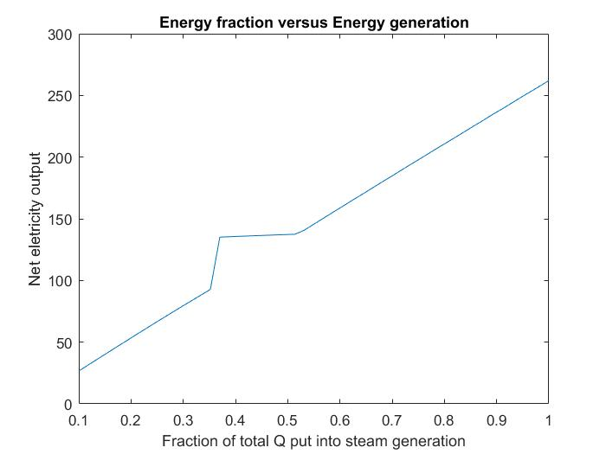

Above is a graph of the energy that is generated versus the fraction of the energy we put into the system. Now we notice that it is mostly linear and this is because the code does not yet account for the change in turbine efficiency as a function of the inlet steam temperature. The kink is caused by the mass flow rate which is shown in the next graph

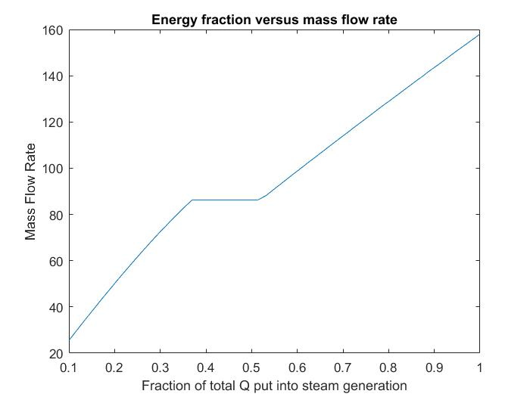

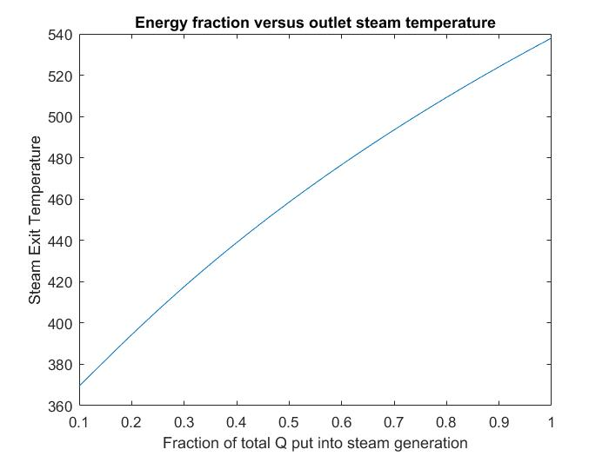

This last graph shows the steam outlet temperature again (out from the SG). This table also has the inlet molten salt temperature along with the saturation temperature of water at that pressure solved by the code. This is to prove that the water is steam at the exit at all times and also below the molten salt inlet temperature.

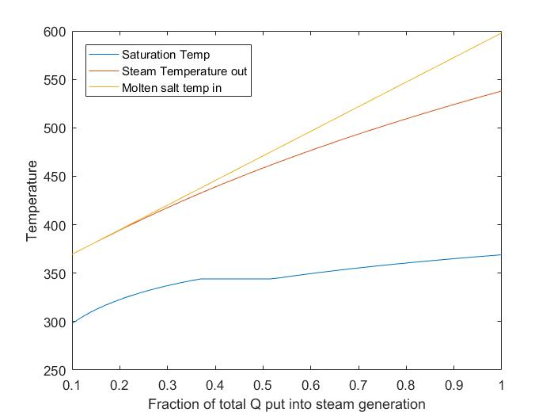

Alternatives

If the temperature and energy characterization relies on too many assumptions then we could also potentially consider the following alternatives:

* Bleeding steam before the HP turbine
  + This will make it such that we are not boiling water in two different locations, the turbine will always receive the same temperature steam which may help longevity, and the mass flow rate does not have to be altered
* Diverting some molten salt to the secondary process
  + The molten salt that is not diverted is always the same temperature before entering into the SG (meaning that heat quality is higher for both components)

More research should be performed on super-critical coal plants that load follow through throttling and Load following using sliding pressure operation